*2019 Anomaly Event Detection using Generative Adversarial Network for Surveillance Videos*

Generator: Unet. Discriminator: 2D CNN.

**Abstract:**

They propose unsupervised anomaly event detection using Generative Adversarial Network (GAN) with Optical Flow to obtain spatiotemporal features in appearance and motion representations.

Any unknown events are considered as the anomaly event which can be detected by subtracting the pixels between the generated and the real optical flow images.

**Spatiotemporal Translation Network for Normal Pattern Learning:**

The proposed GAN model is used to generate the optical flow ($O_{g_{t}}$) from the background removal frame ($f_{{br}_{t}}$) at time t, while the ground truth of optical flow ($O_{r_{t}}$) is obtained by using two consecutive frames in “Fast Optical Flow using Dense Inverse Search”.

This proposed framework uses the Dropout technique in the Decoder of G to perform as the random noise z.

The input of G is a background removal frame at time t obtained by computing the absolute difference between two consecutive frames.

G generates the output image $g=G\left(x,z\right)=O_{g_{t}}$, corresponding to the target image $y=O_{r_{t}}$.

D outputs a scalar signified the probability.

At training time, a Generator Loss $L_{L1}$ and a GAN Loss $L_{GAN}$.

$$L_{L1}\left(G\right)=E_{x,y,z}\left[{\left\|y-G(x,z)\right\|}_{1}\right]$$

$$L_{GAN}\left(G,D\right)=E_{y}\left[logD(y)\right]+E_{x,z}\left[log⁡(1-D(G(x,z)))\right]$$

$$G^{*}=arg\min_{G}{\max_{D}{L_{GAN}\left(G,D\right)+λL_{L1}(g)}}$$

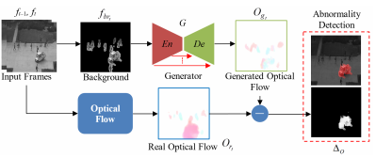

**Anomaly Detection:**

At testing time, G is the only network used for reconstructing the learned features.

$$Δ_{o}=O_{r_{t}}-O_{g_{t}}$$

$Δ_{o}$ shows the local difference between two frames.